SpaceX is closer to offering internet service as it completes fifteenth Starlink mission
by Evelyn Arevalo October 24, 2020
Falcon 9 SpaceX Starlink
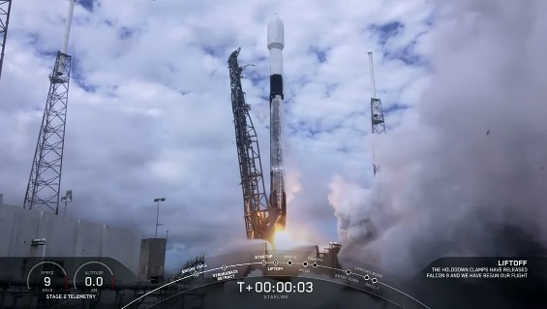
Internet service is an important part of society but millions around the globe still lack access to the world wide web. SpaceX aspires to connect those who live in rural and remote areas around Earth to the Starlink satellite broadband network. Connecting the rest of the world to the internet offers everyone an equal opportunity to access educational and business opportunities at their fingertips.
SpaceX's Starlink network consists of deploying thousands of internet-beaming satellites to low Earth orbit. With over 800 satellites already in orbit, SpaceX is providing broadband service to the Hoh Tribe - an Indian community in Washington State. The Vice Chairman for the Hoh Tribe Melvinjohn Ashue says his community lives in a very remote area, "It seems out of nowhere SpaceX came up and catapulted us into the 21st century. Our youth are able to do education online ... Telehealth is no longer gonna' be an issue, as well as telebehavioral health..." Ashue said early October. Starlink users receive internet from space via 19-inch dish terminals that are pointed to the sky.
SpaceX announced it will also provide internet service to a rural community and school district in West Texas. "Starting in 2021, Starlink will connect up to 45 households in the community as part of the pilot program. As network capabilities continue to grow, it will then expand service to an additional 90 households in the school district," company representatives stated.
Today, October 24th, the company launched the fifteenth fleet of 60 Starlink satellites to orbit. The constellation was increased to approximately 888 satellites. Company officials previously said 800 satellites could offer "moderate" internet coverage. With today's launch, SpaceX is closer to offering internet service to the public. Starlink will soon be offered to the northern United States and southern Canada.
Early Saturday at around 11:31 a.m. EDT, a previously flown Falcon 9 rocket lifted off carrying the 60 satellites from pad Space Launch Complex-40 at the Cape Canaveral Air Force Station in Florida. The launch marked the company's 100th successful flight!

