Uranus might have two dark moons we’ve never seen before
More moons round Uranus?
NASA/JPL/STScI
By Ken Croswell
Uranus may have two small moons that no one has ever seen, orbiting closer to the planet than any of its other satellites and making wavy patterns in the planet’s rings.
The ice giant has 27 known moons, far fewer than the 67 and 62 of its neighbours Jupiter and Saturn, respectively. Uranus is a smaller planet, which may explain the difference.
But it might just be that we haven’t previously had a chance to look for more moons. Unlike its larger brethren, Uranus has entertained only one passing spacecraft – Voyager 2, which tripled the number of known Uranian moons in its 1986 flyby. Uranus is also yet to receive an orbiting spacecraft like Jupiter’s Galileo and Juno, or Saturn’s Cassini.
In addition to its moons, Uranus has dark, narrow rings. Scientists detected the first of these in 1977, when the planet and its rings blocked the light from a distant star. Voyager 2 later discovered two moons, Cordelia and Ophelia, on either side of the outermost ring, named Epsilon. The gravitational pulls of the two moons herd the ring’s particles into a narrow formation.

Small, dark satellites
Now planetary scientists Rob Chancia and Matthew Hedman at the University of Idaho in Moscow have re-examined Voyager data and discovered wavy patterns in two other rings, Alpha and Beta. These may similarly arise from the gravitational tug of a moon that lies outside each ring.
“These moons are pretty tiny,” says Chancia, at only 4 to 14 kilometres across if they exist. That means they’re probably smaller than any Uranian satellite known – and too diminutive for Voyager to have seen clearly. Still, at least four of Saturn’s moons are even smaller.
The two putative moons are probably dark, based on the colours of their neighbours. “Not only are Uranus’s rings dark, so are most of the little satellites that are in that region,” says Hedman.
The existence of the two moons is “certainly a very plausible possibility”, says Mark Showalter of the SETI Institute in Mountain View, California, who has discovered moons around Saturn, Uranus, Neptune and Pluto.
In the coming months, Showalter and his colleagues will examine observations of Uranus by the Hubble Space Telescope, which spotted Pluto’s four smallest moons years before the New Horizons spacecraft visited in 2015. He calls Hubble “the best bet” for finding the Uranian satellites, adding that characterising their orbits is very useful.
If a Hubble search fails, a Uranus orbiter could someday succeed – or else rule out the moons’ existence altogether. “That would definitely be a good way to do it,” says Hedman.
Journal reference: The Astronomical Journal, in press, arxiv.org/abs/1610.02376
Update [17 October]: An earlier version of this article said the paper was in press in the Astrophysical Journal, when it is actually the Astronomical Journal. This has been corrected.

Meet The People Shaping The Future Of Energy:
Reinventing Energy Summit - 25 November in London
- Home
- News
- Earth
182
DAILY NEWS

4 November 2016

Huge lake discovered 15 kilometres under a volcano
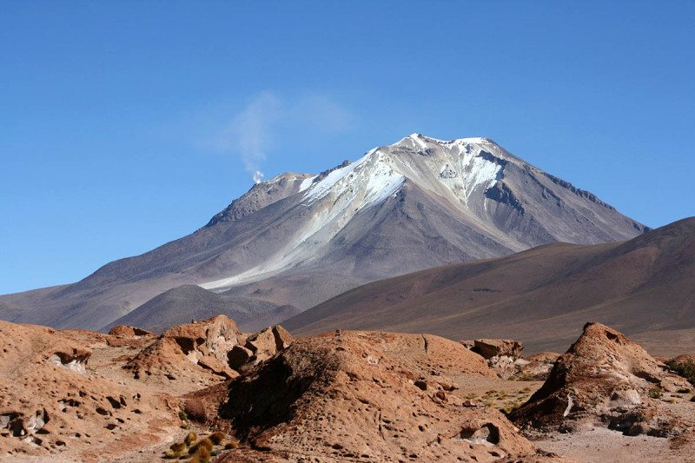
Landscape showing the Uturuncu volcano
Michael Sayles/Alamy Stock Photo
By Andy Coghlan
Our planet is blue inside and out. A massive reservoir of water has been discovered deep beneath a volcano in the Andes, and Earth’s interior may be dotted with similar wet pockets lurking below other major volcanoes.
The unexpected water, which is mixed with partially melted magma, could help to explain why and how eruptions happen.
This water may also be playing a role in the formation of the continental crust we live on, and could be further evidence that our planet has had water circulating in its interior since its formation.

Deep Earth in a lab
Jon Blundy of the University of Bristol, UK, and his colleagues made the discovery while studying a huge “anomaly” 15 kilometres beneath the currently dormant Uturuncu volcano in the Bolivian Andes. The anomaly, called the Altiplano-Puna magma body, slows down seismic waves and conducts electricity, unlike surrounding magma.
Blundy’s team took rocks that were spat out by an eruption of Uturuncu 500,000 years ago and mixed them with varying amounts of water before exposing them in the lab to conditions mimicking those in the anomaly.
This included pressures 30,000 times as high as atmospheric pressure, and temperatures up to 1500 °C. “We reproduced conditions deep in the Earth in the lab,” says Blundy.
They found that at a particular water content, the electrical conductivity exactly matched the value measured in the anomaly. “By weight, we calculated it contains 8 to 10 per cent water,” says Blundy.

Staggering amount
The Altiplano-Puna magma body is known to be around half a million cubic kilometres in volume, so the researchers estimate it must contain a similar amount of water to some of the largest freshwater lakes on Earth. “It’s probably somewhere between Lake Superior and Lake Huron,” says Blundy. “It’s a staggeringly large amount.”
Other anomalies with similar unexplained conductivity have been discovered beneath other volcanoes, such as those in the Taupo Volcanic Zone in New Zealand, and Mount St Helens in Washington State, which erupted spectacularly in 1980. It’s likely that these are also signs of secret reservoirs.
“This study illuminates a new feature of Earth’s deep-water cycle, and reminds us how little we know about the pathway of water through Earth’s crust and mantle systems on geologic timescales,” says Steve Jacobsen of Northwestern University in Evanston, Illinois, whose team previously discovered a reservoir of water three times the volume of all the oceans 700 kilometres down in the mantle.
Such discoveries add to growing evidence that significant amounts of water exist in Earth’s interior, some of which may even have been the source of today’s oceans. It could be that the water that makes our planet habitable was present in the dust that coalesced to create Earth, rather than arriving later on ice-rich comets or asteroids.

Beyond our reach
We can forget about extracting the newly found water. “It’s dissolved in partially melted rock at 950 to 1000 °C, so it’s not accessible,” says Blundy.
But increased water content in magma may help to explain the composition of continental crust rocks. When magma in the mantle – mainly composed of basalt – rises up into the crust, the water helps to enrich the basalt with silica and deplete it of magnesium, eventually forming rocks like the andesite found beneath the Andes.
“The process in Uturuncu is a microcosm of continental crust formation, and involves much more water than we thought, probably twice as much,” says Blundy.
Water is also one of the volatile components dissolved in magma that drive volcanic eruptions, he says. “Dissolved at shallower depths where the pressure is lower, it comes out as bubbles, which end up as an explosive eruption.”
In the future, understanding more about how water can trigger eruptions could help volcanologists better interpret seismic activity, perhaps improving predictions. “Our results will hopefully improve our ability to interpret these signals of unrest,” says Blundy.
Journal reference: Earth and Planetary Science Letters, DOI: 10.1016/j.epsl.2016.10.023
Read more: Iceland drills hottest hole to tap into energy of molten magma

Meet The People Shaping The Future Of Energy:
Reinventing Energy Summit - 25 November in London
- Home
- News
- Health
- Life
17
SHORT SHARP SCIENCE

10 November 2016

UK red squirrels are carrying leprosy and have been for decades
Facing yet another threat
Pauline Lewis/Getty
By New Scientist staff and Press Association
A study of 110 dead red squirrels from around the UK and Ireland has found that the animals carry several strains of leprosy.
Red squirrels in Scotland, Ireland and the Isle of Wight were found to be carrying Mycobacterium lepromatosis, a bacterial strain that is closely related to a virulent form of human leprosy endemic in Mexico and the Caribbean. Animals on Brownsea Island in Poole harbour carried a different type, Mycobacterium leprae, which is known to have affected people living in southern England over 700 years ago.
The chances of catching the disease from a squirrel are extremely low, and researchers have urged people living close to the animals not to panic. Instead, the finding is more of a concern for those trying to conserve the animals, which are already threatened by squirrelpox and habitat loss.
“We need to understand how and why the disease is acquired and transmitted among red squirrels so that we can better manage this iconic species,” says Anna Meredith, at the University of Edinburgh.

Human strain
Not all the infected squirrels were displaying symptoms. Those that did showed signs of swelling and hair loss from the ears, muzzle and feet.
In humans, leprosy causes nerve and muscle damage which can lead to deformity, disability and blindness if left untreated. However, most healthy people are naturally immune to leprosy and are unlikely to be affected if they are exposed to the bacteria.
The strain carried by the Brownsea Island squirrels was particularly surprising, bearing a similarity to a type of leprosy that was previously found in the 730-year-old skeleton of a leprosy victim buried in Winchester, just 43 miles away.
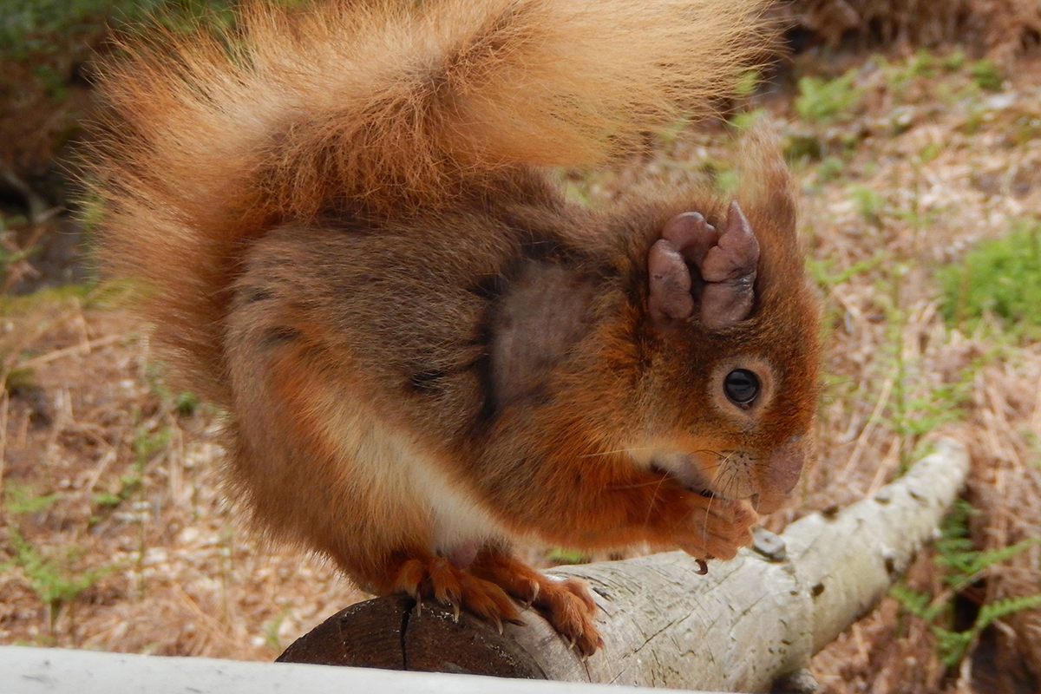
The disease affects the animals’ ears
Dorset Wildlife Trust/PA Wire
The discovery of this medieval leprosy strain in the Brownsea Island so long after it was eliminated from humans was completely unexpected, says team-member Stewart Cole, at the Ecole Polytechnique Federale de Lausanne in Switzerland. “This has never been observed before.”
There are currently around 250 red squirrels on Brownsea Island. Of the 25 dead squirrels the team tested, every one was infected with this leprosy strain.
The last recorded case of indigenous leprosy contracted in the UK dates back to 1798.

Carried for centuries
The team’s findings suggests that the Brownsea squirrels may have been affected by leprosy for centuries.
“Brownsea’s wild red squirrel population has been living with leprosy for at least four decades,” says Angela Cott, National Trust general manager for Brownsea Island. “By working with the University of Edinburgh and Dorset Wildlife Trust, we hope to understand how best to look after Brownsea’s wild red squirrels.”
Fewer than 140,000 red squirrels remain in the UK, and the animals may be extinct in Britain within the next 10 years.
Journal reference: Science, DOI: 10.1126/science.aah3783
Read more: To wipe out leprosy, we have to find it

Meet The People Shaping The Future Of Energy:
Reinventing Energy Summit - 25 November in London
- Home
- News
- Technology
56
TECHNOLOGY NEWS

26 October 2016

Robot learns to play with Lego by watching human teachers
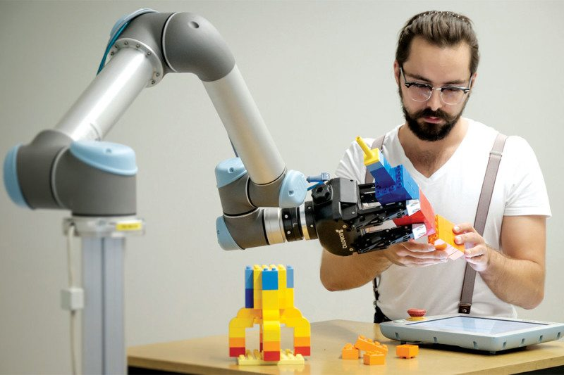
Rocket science, with Lego
David Vogt, Arizona State University/TU Freiburg
By Aviva Rutkin
DAVID VOGT’S son loves Lego. As they played together one day, the robotics professor had an idea: could he teach a robot to put the blocks together?
“We thought it would be funny to make a robot that could do the same thing I am doing with my son,” says Vogt, who is at the Freiberg University of Mining and Technology in Germany.
So Vogt and his colleagues brought an industrial robot arm to the lab. Like a child playing for the first time, the robot – equipped with a Kinect depth camera – observed two experienced humans wearing motion tracking tags as they built a Lego rocket. After just one session, the robot was able to partner with a human to build the rocket. It could also cope with some blocks not being exactly where it expected to find them.
The project, to be presented next month at the International Conference on Humanoid Robots in Cancun, Mexico, is one of several recent examples of teaching robots through human demonstration.
Humans learn how to do lots of things by watching someone else, but programming a new skill into robots is difficult, says Aude Billard at the Swiss Federal Institute of Technology in Lausanne. We know intuitively how to do certain tasks, but struggle to express that knowledge as programming.
Instead, engineers have found ways to show robots what to do, rather than tell them. Some remotely control the robot through its first few tries, getting a sense of its experience using the buzz of haptic feedback. And last year, a robot at the University of Maryland started learning to cook by watching YouTube videos of people in the kitchen.
“A good teacher will understand that the robot has different ways of perceiving the world“
In work published earlier this month, researchers at Google took a hands-on approach, teaching a robot how to open a door by physically guiding it through each step. Later the robot tried on its own, starting with a similar door. It was then able to apply what it had learned to open doors even when their orientation was different to what it had encountered before.
“We have a lot of intuition about how various manipulation skills can be performed, and it only seems natural that transferring this intuition to robots can help them learn these skills a lot faster,” the Google researchers wrote.
Another trick is to make sure the data is translated in a way that makes sense for that particular robot. Most robots don’t have structures or sensors that mirror the human anatomy, for example. “Part of being a good teacher is understanding that the device that you’re teaching has different ways of acting in the world and different ways of perceiving it,” says Billard.
Vogt’s team thinks that learning through human demonstrations will make robots better able to assist humans with skilled factory work. This could mean having the right tool ready when a worker needs it or stepping in to perform some tasks on its own. That could relieve some of the physical stress on workers, says team member Heni Ben Amor at Arizona State University in Tempe.
“Ideally, humans and robots together should be able to do something that, individually or separately, they wouldn’t have been able to do alone,” he says.
This article appeared in print under the headline “Robots: just look at me and copy what I do”

Meet The People Shaping The Future Of Energy:
Reinventing Energy Summit - 25 November in London
- Home
- News
- Technology
39
TECHNOLOGY NEWS

26 October 2016

Playing Grand Theft Auto can teach autonomous cars how to drive
Getting computers to recognise other cars is surprisingly difficult – but super-realistic video games can help train them up
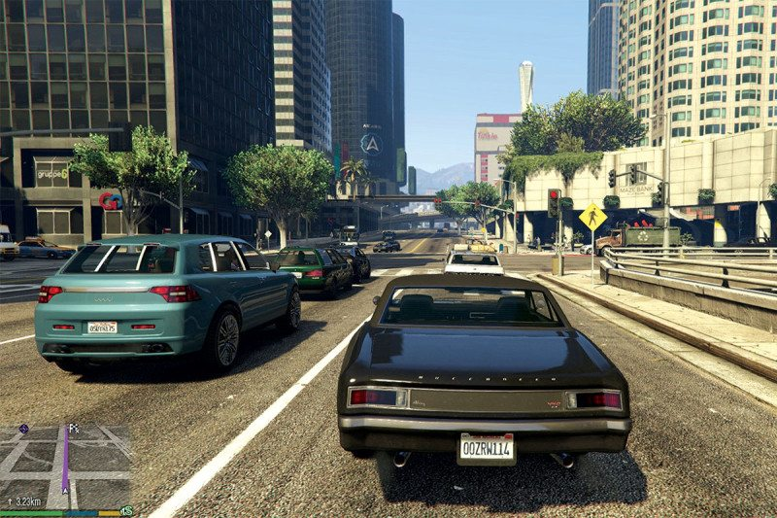
Driver 1: ready
Rockstar Games
By Timothy Revell
GETTING computers to recognise other cars is surprisingly difficult. Earlier this year, the first fatal autonomous car crash happened when a Tesla Model S failed to distinguish a white truck against a brightly lit sky.
Now a study has shown that self-driving cars can be taught the rules of the road by studying virtual traffic on video games such as Grand Theft Auto V (GTA V).
Although firms like Google and Uber are teaching their software by physically driving millions of miles in the real world, they also train their algorithms using pre-recorded footage of traffic. But there’s a catch: computers need hundreds of thousands of laboriously labelled images, showing where vehicles begin and end, to make them expert vehicle recognisers. That takes people a lot of time and effort.
“One evening, after a long day of hand-labelling images, I was playing Grand Theft Auto V,” says Matthew Johnson-Roberson at the University of Michigan in Ann Arbor. “I thought, ‘this is just so realistic that it would be a perfect simulation of the real world’.”
Picking out cars in a video game is a similar task to doing it in reality, with the advantage that everything comes pre-labelled because it has been generated by the game’s software. The team trained an algorithm solely using GTA Vand tested it against the same algorithm trained on real-world images. The GTA-trained one performed just as well at spotting cars in a pre-labelled data set (arxiv.org/abs/1610.01983). The video-game version needed around 100 times more training images to reach the same standard – but given that 500,000 images can be generated from the game overnight, that is not a problem.
“I thought, ‘this is just so realistic that it would be a perfect simulation of the real world’“
This isn’t the first time a research group has used video games to train AI, says German Ros at the Autonomous University of Barcelona in Spain. “It’s part of a bigger movement of using simulations to train artificial intelligence, which is beginning to take off.”
Finding the right training data is difficult. “We see AI being trained on images from similar locations, at similar times of day, under similar weather conditions, and then tested under similar conditions,” says Ros. This means that it’s hard to tell whether the computers can genuinely recognise cars, or whether they have just memorised that particular data set.
Using video games can help because they often show a variety of vehicles and conditions – but the problem is still there. “There’s nothing in GTA V that looks like a city in Japan, for example,” says Ros.
We have to show that driverless cars are safer than human-driven ones. In the real world, there is a car fatality for every 100 million miles driven. Racking up that kind of distance with a prototype is not easy. “The first step could be to make sure every system has been tested using video-game-style simulations before it hits the road,” says Johnson-Roberson.
This article appeared in print under the headline “Play it for real”

The road to artificial intelligence: A case of data over theory
Computers that could simulate human intelligence were once a futuristic dream. Now they are all around us – but not in the way their pioneers expected
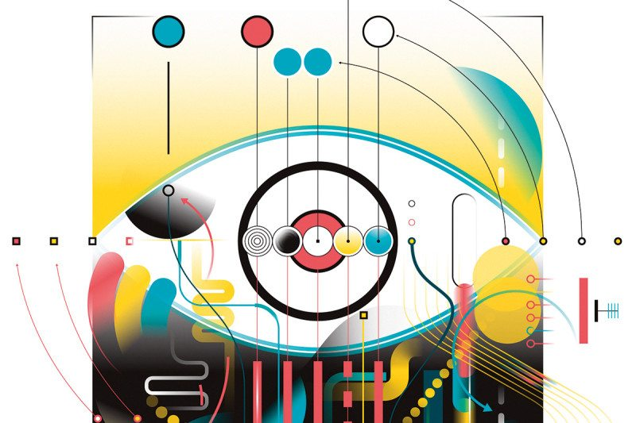
Leandro Castelao
By Nello Cristianini
IN the summer of 1956, a remarkable collection of scientists and engineers gathered at Dartmouth College in Hanover, New Hampshire. Among them were computer scientist Marvin Minsky, information theorist Claude Shannon and two future Nobel prizewinners, Herbert Simon and John Nash. Their task: to spend the summer months inventing a new field of science called “artificial intelligence” (AI).
They did not lack in ambition, writing in their funding application: “every aspect of learning or any other feature of intelligence can in principle be so precisely described that a machine can be made to simulate it.” Their wish list was “to make machines use language, form abstractions and concepts, solve kinds of problems now reserved for humans, and improve themselves”. They thought that “a significant advance can be made in one or more of these problems if a carefully selected group of scientists work on it together for a summer.”
It took rather longer than a summer, but 60 years and many disappointments later, the field of AI seems to have finally found its way. In 2016, we can ask a computer questions, sit back while semi-autonomous cars negotiate traffic, and use smartphones to translate speech or printed text across most languages. We trust computers to check passports, screen our correspondence and fix our spelling. Even more remarkably, we have become so used to these tools working that we complain when they fail.
As we rapidly get used to this convenience, it is easy to forget that AI hasn’t always been this way.
At the Dartmouth conference, and at various meetings that followed it, the defining goals for ...

