SAFETY SYSTEMS OF NUCLEAR POWER PLANTS
Belarusian State University of Informatics and Radioelectronics
Minsk, Republic of Belarus
Gitlik A.S.

Lazarenko A.M. - Senior Lecturer

The purpose of this paper is to study the safety systems of nuclear power plants, to analyze their structure and learn the details of Belarusian nuclear power plant safety systems.

The relevance of this work was confirmed by the small study at our university. The written survey consisting of 4 points related to nuclear power plant (NPP) safety systems, for which the students gave answers that confirmed the fact that few of them knew enough about the safety of nuclear power plants, was carried out.
In today's world, in many countries there are no alternatives to nuclear power, a worthy replacement for the enormous amount of energy gained from this area. So, sufficient theoretical information has been gathered on the topic, after which it was considered in detail.
ОБРАЗЕЦ
NPP safety systems are designed to prevent accidents and limit their consequences. These systems are divided into protective, localizing, managing, providing safety systems.
Protective systems are created to prevent or limit damage to the nuclear fuel, fuel cladding and the primary circuit shell. The main protective systems are the emergency reactor shutdown and emergency heat removal from it.
Localizing systems are designed to prevent or limit the spread of radioactive substances during the accidents within the NPP and its emission into the environment.
Control systems carry out activation, control and managing of the safety systems during the process of performing the specified functions.
Support systems supply energy, work environment to the safety systems, and create conditions for their functioning.
The collection and analysis of information allows us to determine that the most effective way to ensure safety is to use the passive mode of operation, which has become a key element of consideration in this paper. After comparing the safety systems of the Russian reactor type (VVER 1200) with major world reactor types (namely the American analog AP-1000) the following conclusions were made:
- The passive safety systems ensure the safety of Ostrovets NPP equally with world counterparts.
- In the project the new devices of passive safety system were implemented: second stage of gydroelastics
(GE-2, that is shown in Figure 1), the passive removal system of steam heat generators (SPOT) and the melt localization device (ULR).
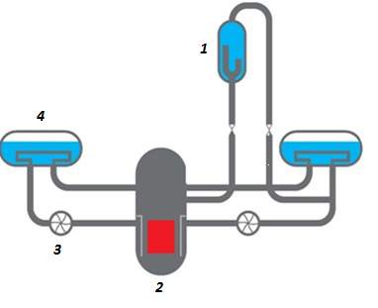
Figure 1. “The second stage of gydroelastics ”
1.GE-2
2.Reactor
3.Pump
4.Steam generator

References:
http://b-energy.ru/biblioteka/bezopasnost-aes-ekologiya/343-sistemy-bezopasnosti-atomnyh-elektrostancii-aes.html
http://www.dsae.by/ru/besopasnost_url_286470152
http://www.myshared.ru/slide/641859/
http://energetika.in.ua/ru/books/book-4/part-1/section-7/7-1

