ПРИМЕР ПЕРЕВОДА ДИПЛОМОВ И ПРИЛОЖЕНИЙ К НИМ

Образец диплома о профессионально-техническом образовании
(на русском и английском языке)

ДЫПЛОМ Д N 0000000 DIPLOMA (with Distinction)
аб прафесiянальна-тэхнiчнай адукацыi Д No. 0000000
(з адзнакай) of Vocational Technical Education

Гэты дыплом выдадзены ______________ This diploma is issued to __________
____________________________________ ____________________________________
у тым, што ён (яна) __ _____ 20__ г. to certify that he (she) in 20__
паступi___ entered ____________________________
у __________________________________ ____________________________________
____________________________________ ____________________________________
____________________________________ ____________________________________
____________________________________ ____________________________________
i __ _______ 20__ г. скончы__ поўны and in 20___ completed the full
курс ________ course _________
____________________________________ ____________________________________
____________________________________ ____________________________________
агульнай сярэдняй адукацыi па general secondary education, having
спецыяльнасцi ______________________ specialized in _____________________
____________________________________ ____________________________________
____________________________________ ____________________________________
____________________________________ ____________________________________
____________________________________ ____________________________________
____________________________________ ____________________________________
____________________________________ ____________________________________
Рашэннем дзяржаўнай квалiфiкацыйнай By the Decision of the State
камiсii ад Qualification Board issued
__ _______ 20__ г. _________________ _____ ___, 20__________ ____________
прысвоена квалiфiкацыя _____________ is qualified as ____________________
____________________________________ ____________________________________
____________________________________ ____________________________________

Меcца для фота Seal
i пячаткi
Старшыня дзяржаўнай квалiфiкацыйнай Chairperson of the State
камiсii Qualification Board
____________________________________ ____________________________________
Кiраўнiк установы адукацыi _________ Head of the Educational Institution
Намеснiк кiраўнiка ўстановы адукацыi ____________________________________
____________________________________ Deputy Head of the Educational
Institution ________________________
Выдадзены __ ____ 20__ г. Issued _______ ___, 20__
Рэгiстрацыйны N ______ Registration No. ________

Образец диплома о среднем специальном образовании
(на русском и английском языке)

РЕСПУБЛИКА БЕЛАРУСЬ REPUBLIC OF BELARUS
ДИПЛОМ О СРЕДНЕМ СПЕЦИАЛЬНОМ DIPLOMA WITH DISTINCTION
ОБРАЗОВАНИИ C ОТЛИЧИЕМ OF VOCATIONAL SECONDARY EDUCATION

А N 0000000 A No. 0000000

Настоящий диплом выдан _____________ This diploma is issued to __________
____________________________________ ____________________________________
____________________________________ ____________________________________
в том, что _____ в ________ году to certify that he (she) in ________
поступил_____ в ____________________ entered ____________________________
____________________________________ ____________________________________
____________________________________ ____________________________________
и в 20___ году окончил___ полный ___ and in ____ completed the full
курс _______________________________ course _____________________________
____________________________________ ____________________________________
____________________________________ ____________________________________
____________________________________ ____________________________________
____________________________________ ____________________________________
________ по специальности __________ _______ having specialized in ______
____________________________________ ____________________________________
____________________________________ ____________________________________
Решением государственной By the Decision of the State
квалификационной комиссии от Qualification Board issued
__ _________ 20__ г. _______________ _________ ___, 20___ _______________
____________________________________
присвоена квалификация _____________ is qualified as ____________________
____________________________________ ____________________________________
Председатель государственной Chairperson of the State
квалификационной комиссии __________ Qualification Board ________________

Место для фото Seal
и печати

Руководитель учреждения образования Head of the Educational Institution
____________________________________ ____________________________________
Секретарь __________________________ Secretary __________________________

Город _________ __ _________ 20__ г. City _________ __________ ____, 20__
Регистрационный N ________________ Registration No. ________________

Образец диплома о высшем образовании
(на русском и английском языке)

┌────────────────────────────────────┬────────────────────────────────────┐
│ │ │
│ РЕСПУБЛИКА БЕЛАРУСЬ │ REPUBLIC OF BELARUS │
│ │ │
│ ДИПЛОМ О ВЫСШЕМ ОБРАЗОВАНИИ │ DIPLOMA OF HIGHER EDUCATION │
│ │ │
│ ДИ N 0000000 │ ДИ No. 0000000 │
│ │ │
│Настоящий диплом выдан _____________│This diploma is issued to __________│
│____________________________________│____________________________________│
│____________________________________│____________________________________│
│в том, что _________ в 20__ году │to certify that he (she) in 20__ │
│ (он, она) │entered ____________________________│
│поступил__ в _______________________│____________________________________│
│____________________________________│____________________________________│
│____________________________________│____________________________________│
│____________________________________│____________________________________│
│и в 20__ году окончил__ полный курс │and in 20___ completed the full │
│____________________________________│course _____________________________│
│____________________________________│____________________________________│
│____________________________________│____________________________________│
│по специальности ___________________│having specialized in ______________│
│____________________________________│____________________________________│
│____________________________________│____________________________________│
│____________________________________│____________________________________│
│Решением государственной │By the Decision of the State │
│экзаменационной комиссии от │Examination Board │
│__ _________________ 20__ г. │issued ______________ __, 20__ │
│протокол N _________________________│minutes No. ________________________│
│присвоена квалификация _____________│is qualified as ____________________│
│____________________________________│____________________________________│
│Настоящий диплом дает право на │By this diploma he (she) is │
│самостоятельное выполнение всех │entitled to carry out any │
│работ, связанных с полученными │professional activities connected │
│квалификацией и специальностью. │with the above-mentioned │
│ │qualification and │
│Председатель государственной │speciality/specialization. │
│экзаменационной комиссии │Chairperson of the State │
│ │Examination Board │
│Место Руководитель учреждения │Seal │
│для фото образования │Head of the Educational Institution │
│и печати │ │
│ Декан (начальник) │Dean (Head) of the Faculty │
│ факультета │ │
│ │ │
│Город _________ __ _________ 20__ г.│City________ _________ ___, 20___ │
│Регистрационный N __________________│Registration No. _________________ │
└────────────────────────────────────┴────────────────────────────────────┘

Образец приложения к диплому о высшем образовании

Supplement to Diploma A № 0888274

Academic Transcript
(not valid without Diploma)

__________________________________
(Full Name)

within the course of studies at the educational institution “Belarusian State University of Informatics and Radioelectronics”, Faculty of ______________ from September 01, 2008 till June 30, 2013 having specialized in “_______________”, specialization “___________________” studied the following subjects and had shown the following academic performance:

No. | Subjects | Total Number of Academic Hours | Marks
 |  |  | Exam | Credit
1.
2.
3.
No. | Term Papers (Works) | Total Number of Academic Hours | Marks
1.
2.
3.
No. | Practical Trainings | Total Number of Academic Hours | Marks
1.
2.
3.

Passed State Examination in the speciality “________________”, specialization “_________________” with the mark “_________”.

Presented a diploma paper (project) on the topic “________________” and defended it with the mark “______”.

Vice-Rector for Education and Quality Management | /stamped and signed/ | ________
Faculty Dean  Faculty Secretary | /signed/  /signed/ | _______  _______
City Minsk, June 30, 20___ Registration No. ____

Translation is correct.
BSUIR International Relations Department Head Elena Bakunova

Образец диплома магистра
(на русском и английском языке)

┌────────────────────────────────────┬────────────────────────────────────┐
│ │ │
│ РЕСПУБЛИКА БЕЛАРУСЬ │ REPUBLIC OF BELARUS │
│ │ │
│ ДИПЛОМ МАГИСТРА │ MASTER'S DEGREE DIPLOMA │
│ │ │
│ ДИ N 0000000 │ ДИ No. 0000000 │
│ │ │
│Настоящий диплом выдан _____________│This diploma is issued to __________│
│____________________________________│____________________________________│
│в том, что _________ в 20__ году │to certify that he (she) in 20______│
│ (он, она) │took a Master's degree course ______│
│поступил__ в магистратуру __________│____________________________________│
│____________________________________│____________________________________│
│____________________________________│____________________________________│
│____________________________________│____________________________________│
│и в 20__ году окончил__ магистратуру│and in 20___ completed a Master's │
│____________________________________│degree course ______________________│
│____________________________________│____________________________________│
│____________________________________│having specialized in ______________│
│по специальности ___________________│____________________________________│
│____________________________________│____________________________________│
│____________________________________│By the Decision of the State │
│Решением государственной │Examination Board │
│экзаменационной комиссии │issued _________ ___, 20 ______ │
│от __ _____________ 20__ г. │minutes No. ________________________│
│протокол N _________________________│____________________________________│
│присвоена степень магистра _________│is qualified as Master of __________│
│____________________________________│____________________________________│
│____________________________________│By this diploma he (she) is entitled│
│Настоящий диплом дает право на │to carry out any professional │
│самостоятельное выполнение всех │activities connected with the above-│
│работ, связанных с полученными │mentioned qualification and │
│квалификацией и специальностью. │speciality/specialization. │
│ │ │
│Председатель государственной │Chairperson of the State │
│экзаменационной комиссии │Examination Board │
│ │ │
│Место Руководитель учреждения │Head of the Educational Institution │
│для фото образования │ │
│и печати │ │
│ Декан (начальник) │Dean (Head) of the Faculty │
│ факультета │ │
│ │ │
│Город _______ __ ___________ 20__ г.│City _______ ____________ ___, 20__ │
│Регистрационный N _________________ │Registration No. ________________ │
└────────────────────────────────────┴────────────────────────────────────┘

Образец приложения к диплому магистра
Supplement to Diploma A № 0030335
ACADEMIC TRANSCRIPT
(not valid without diploma)
______________________
(full name)
within the course of studies at the Master’s Degree course of the educational institution «Belarusian State University of Informatics and Radioelectronics» from September 1, 2013 till June 30, 2014 having specialized in «_________________», studied the following subjects and had the following academic performance:
Subjects | Total number of academic hours | Marks, credits
 |  | exam | credit
Presented a Master's thesis on the topic «_________» and defended it with the mark «_____».
Vice-Rector for Academic
and Social Affairs /signature, Universdity stamp/ A. Khmyl
Master Programmes, Head /signature/
Master Programmes, Supervisor /signature/
Minsk City, June 30, 20___ Registration No.___
Translation is correct.
International Relations Department Head Elena Bakunova
Belarusian State University
of Informatics and Radioelectronics

Образец диплома исследователя
(на русском и английском языке)

┌────────────────────────────────────┬────────────────────────────────────┐
│ │ │
│ РЕСПУБЛИКА БЕЛАРУСЬ │ REPUBLIC OF BELARUS │
│ │ │
│ ДИПЛОМ ИССЛЕДОВАТЕЛЯ │ RESEARCHER'S DIPLOMA │
│ │ │
│ ДД N 0000000 │ ДД No. 0000000 │
│ │ │
│Настоящий диплом выдан _____________│This diploma is issued to __________│
│____________________________________│____________________________________│
│в том, что __________ в 20__ году │to certify that he (she) in 20__ │
│ (он, она) │took a _________ postgraduate course│
│поступил____________________________│(postgraduate military course) │
│в аспирантуру (адъюнктуру) _________│____________________________________│
│____________________________________│____________________________________│
│____________________________________│____________________________________│
│и в 20__ году окончил__ ____________│and in 20__ completed the full │
│____________________________________│course _____________________________│
│____________________________________│____________________________________│
│по специальности(ям) _______________│____________________________________│
│____________________________________│having specialized in ______________│
│____________________________________│____________________________________│
│____________________________________│____________________________________│
│Решением государственной │____________________________________│
│аттестационной комиссии │By the Decision of the State │
│от __ ______ 20__ г. (протокол N __)│Certification Board │
│____________________________________│issued ___ __, 20__ (minutes No. __)│
│присвоена научная квалификация │____________________________________│
│"Исследователь" │has been conferred the scientific │
│в области __________________________│qualification "Researcher" in │
│Настоящий диплом дает право на │____________________________________│
│самостоятельное │By this diploma he (she) is entitled│
│выполнение научно-исследовательских │to carry out any │
│работ, │scientific and research activities │
│связанных с полученными научной │connected with the │
│квалификацией │above-mentioned qualification and │
│и специальностью. │speciality. │
│ │ │
│Председатель государственной │Chairperson of the State │
│аттестационной │Certification │
│комиссии /подпись/│Board /signature/│
│ │ │
│Место Руководитель учреждения │Head of the Institution /signature/│
│для фото /подпись/ │ │
│и печати │ │
│ Секретарь государственной │Secretary of the State │
│ аттестационной комиссии │Certification Board /signature/│
│ /подпись/│ │
│ │ │
│Город __________ __ _______ 20__ г. │City ___________ ________ ____, 20__│
│Регистрационный N __________________│Registration No. ___________________│
└────────────────────────────────────┴────────────────────────────────────┘

Образец справки об обучении

___________________________________________________________________________
(полное официальное наименование учреждения образования, иной организации,
индивидуального предпринимателя, которым в соответствии с законодательством
предоставлено право осуществлять образовательную деятельность)
___________________________________________________________________________

СПРАВКА ОБ ОБУЧЕНИИ
А N 0000000

Выдана _______________________________________________________________
(фамилия, собственное имя, отчество (если таковое имеется)
в том, что он (она) осваивал(а) ___________________________________________
(наименование образовательной программы)
___________________________________________________________________________
___________________________________________________________________________
с __ __________ 20__ г. по __ ___________ 20__ г.

Справка выдана в связи с отчислением
___________________________________________________________________________
(основания отчисления, дата и номер решения)

Руководитель учреждения образования,
иной организации, индивидуального
предпринимателя ____________________ _______________________
(подпись) (инициалы, фамилия)
М.П.
Город ___________ __ ___________ 20__ г.

Belarusian State University of Informatics and Radioelectronics
full official name of the educational institution, other organization or sole proprietor
which is legally entitled to conduct educational activity

ACADEMIC CERTIFICATE

A No. 0000000

is issued to _____________ and herewith certifies that he has been taking a first-degree programme in ________________, Faculty of ________________. Mode of study is _________. Period of study is from ________ till ____________.
This certificate is issued due to the fact of expel from the university at his own request under the Rector’s order No. ____ dated _______.

No. | Subjects | Total Number of Academic Hours | Marks
 | 1st semester
1.
2.
 | 2nd semester
1.
2.
Director of the educational institution,
other organization or sole proprietor /seal, signature/
Dean /signature/
Secretary /signature/
Registered under No. ___ dated _______, in Minsk.

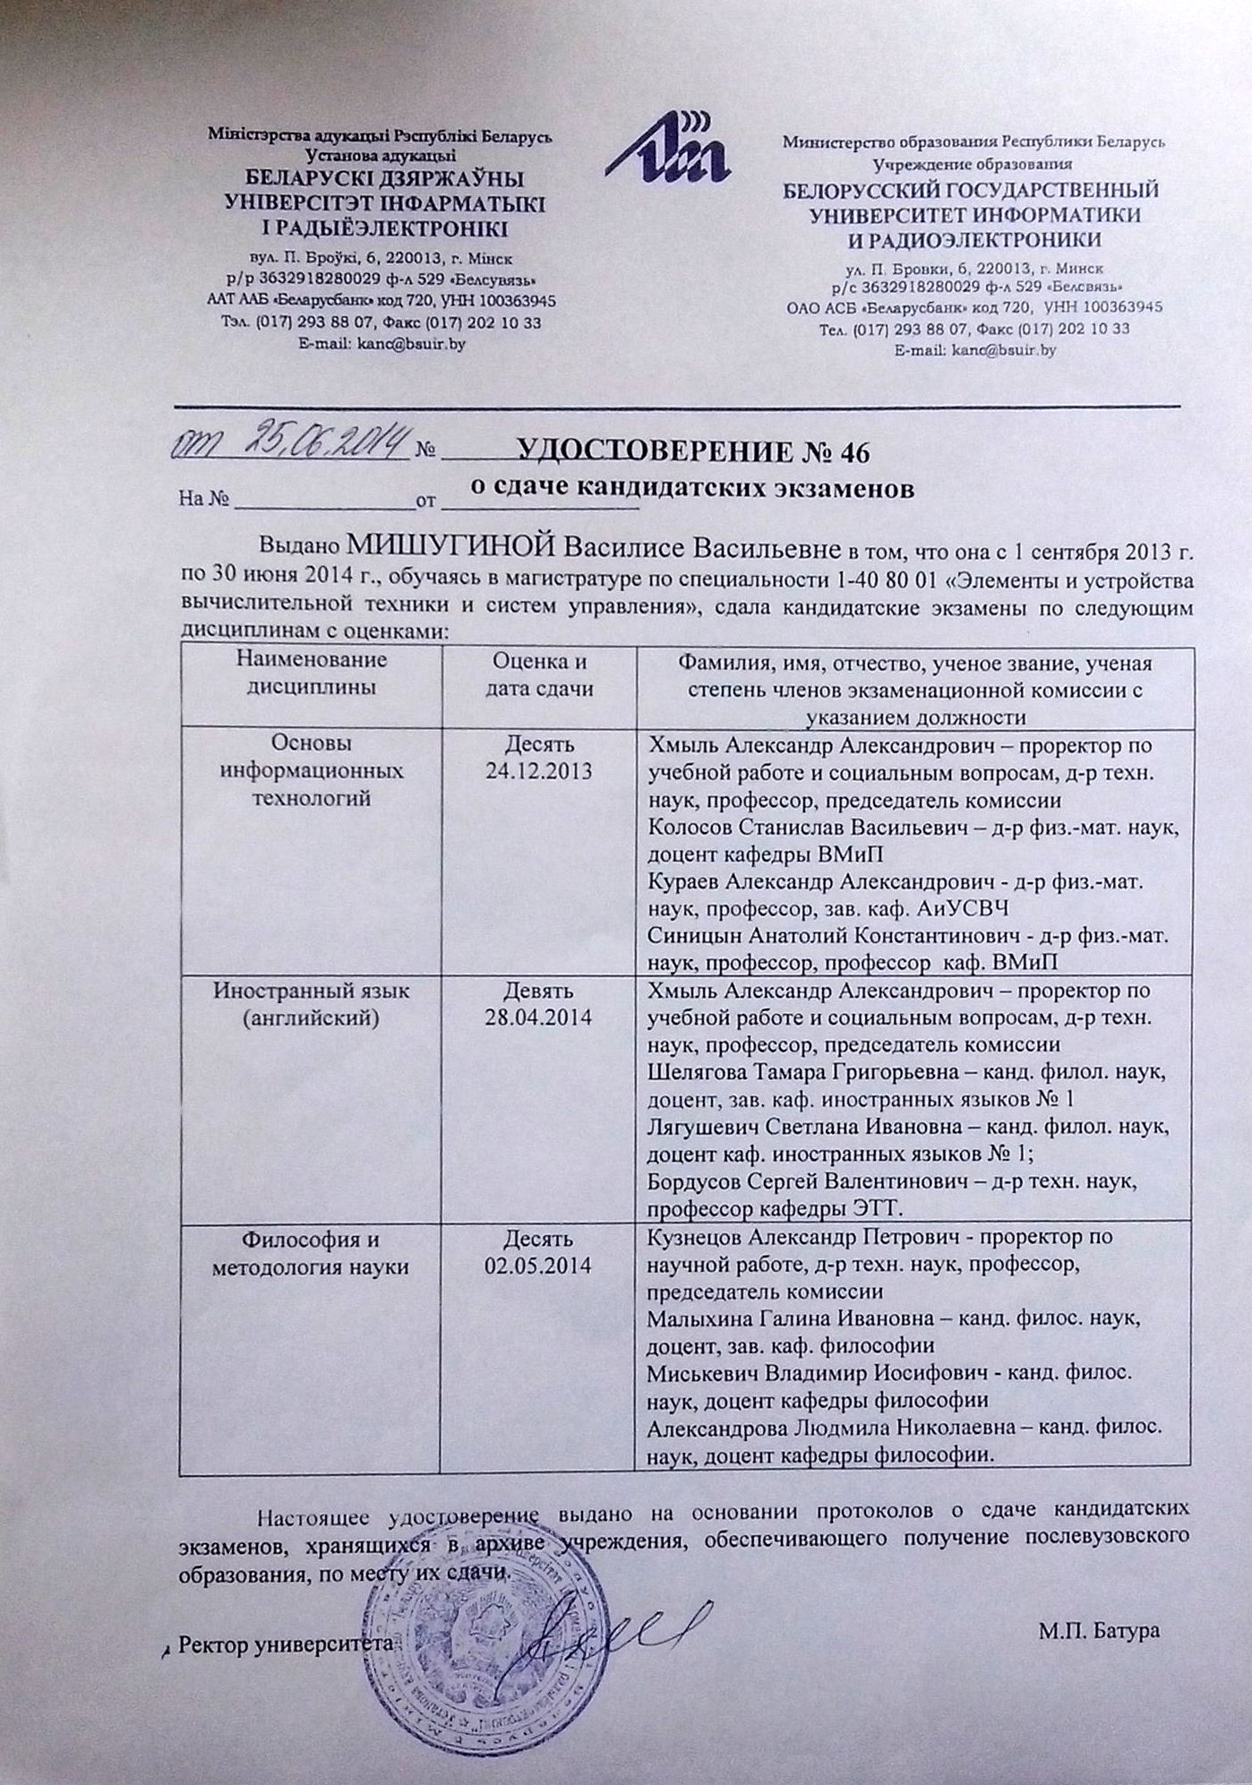

Ministry of Education of the Republic of Belarus
Educational Institution
BELARUSIAN STATE UNIVERSITY OF INFORMATICS AND RADIOELECTRONICS
CERTIFICATE № 46 on PhD Candidacy Examinations
dated June 25, 2014

This is to certify that VASILISA MISHUHINA studied at the Master’s Degree course No. 1-40 80 01 “Components and Devices of Computers and Control Systems” from September 1, 2013 till June 30, 2014 and passed qualifying examinations for admission to PhD studies with the following marks:
Subjects | Mark and  examination date | Full names, academic titles and degrees, positions  of the examination commission members
Basics of Information Technologies | 10 (TEN)  24.12.2013 | Khmyl A. – Vice-Rector for Education and Social Affairs, Dr. Sc. (Eng), Prof., Commission Chair  Kolosov S. – Dr. Sc. (Phys.-Math.), Assoc. Prof., Department of Computational Methods and Programming  Kurayev A. – Dr. Sc. (Phys.-Math.), Prof., Head of Department of Antennas and UHF Devices  Sinitsyn A. – Dr. Sc. (Phys.-Math.), Prof., Department of Computational Methods and Programming
Foreign Language (English) | 9 (NINE)  28.04.2014 | Khmyl A. – Vice-Rector for Education and Social Affairs, Dr. Sc. (Eng), Prof., Commission Chair  Shelyagova T. – Cand. Sc. (Philol.), Assoc. Prof., Head of Department of Foreign Languages No. 1  Lyagushevich S. – Cand. Sc.(Philol.), Assoc. Prof., Department of Foreign Languages No. 1  Bordusov S. – Dr. Sc. (Eng), Prof., Department of Electronic Technology and Engineering
Philosophy and Methodology of Science | 10 (TEN)  02.05.2014 | Kuznezov A. – Vice-Rector for R&D, Dr. Sc. (Eng), Prof., Commission Chair  Malykhina G. – Cand. Sc. (Philos.), Prof., Head of Philosophy Department  Miskevich V. – Cand. Sc. (Philos.), Assoc. Prof., Philosophy Department  Alexandrova L. – Cand. Sc. (Philos.), Assoc. Prof., Philosophy Department
This certificate is issued on the basis of PhD Candidacy examination records, which are being kept by the Archives of the institution of postgraduate education at the place, where examinations were taken.

Rector /Signature, official university stamp/ M. Batura

Translation is correct.
International Relations Department Head Elena Bakunova
Belarusian State University
of Informatics and Radioelectronics

Образец диплома доктора наук
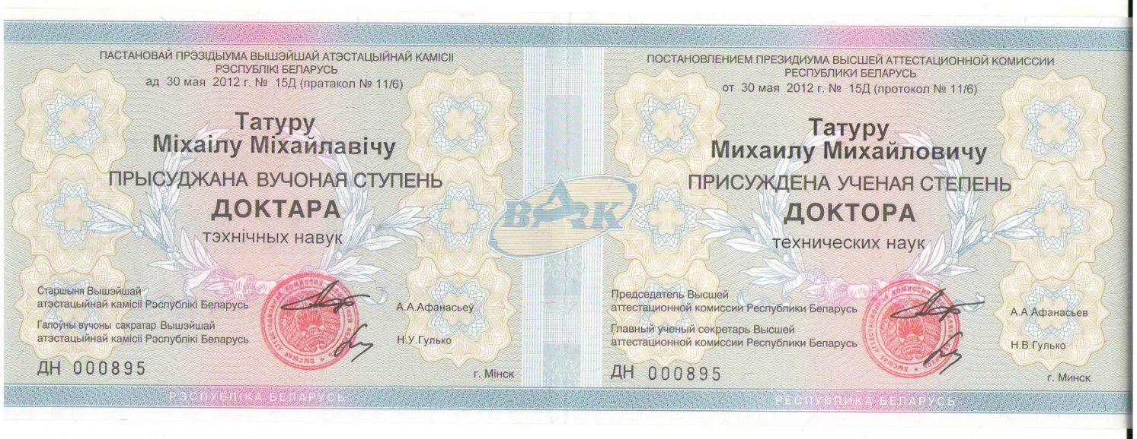
BY THE DECISION
OF THE PRESIDIUM OF THE STATE COMMISSION
FOR ACADEMIC DEGREES AND TITLES
OF THE REPUBLIC OF BELARUS
on May 30, 2012 No.15Д (record No. 11/6)

MIKHAIL TATUR

Is awarded the Academic Degree

of the DOCTOR
of Technical Sciences

Chairman of the State Commission
for Academic Degrees and Titles
of the Republic of Belarus /signature and stamp/ A.A. Afanasyev

Chief Scientific Secretary
of the State Commission
for Academic Degrees and Titles
of the Republic of Belarus /signature/ N.V. Gulko

ДН 000895 Minsk
Republic of Belarus

The text above is presented in two languages: Belarusian on the left, Russian on the right.

Translation is correct.
International Relations Department Head
Belarusian State University of
Informatics and Radioelectronics Elena Bakunova

